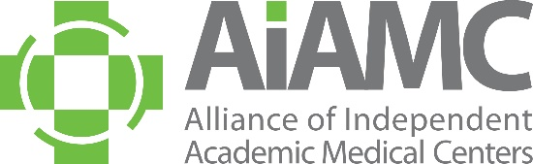

ALLIANCE OF INDEPENDENT
ACADEMIC MEDICAL CENTERS
2022 Annual Meeting
Call for Poster Abstracts

All AIAMC members are invited to submit abstracts for poster presentation at our 2022 Annual Meeting, to be held March 24th thru 26th at the Loews New Orleans Hotel. We encourage you to share this call with AIAMC-member colleagues, especially your residents who may not typically receive these announcements. Abstracts are due no later than September 15, 2021, and all submitting authors will be notified of the committee’s decision in mid-October.

Criteria for Selection:
- Introduction: clearly articulated context for project or research study, including relevant literature
- Hypothesis/Aim Statement: clearly stated purpose of the project or research study
Methods: clear description of how the project was conducted and/or implemented, with sound and appropriate project design
- Results: clear and unambiguous statement of what changed and how
- Conclusions: implications of the project beyond the local setting
All accepted poster presenters are required to register for the conference. Please do NOT submit an abstract if your attendance at the Annual Meeting is questionable. Accepted posters will be on display for the entire conference, i.e., from Thursday, March 24th thru Saturday, March 26th. On Saturday morning, March 26th, the top abstracts chosen for oral presentation will be presented in a “poster slam” format, followed by a staffed poster display of all posters accepted. Poster presenters are asked to make travel plans accordingly. In accordance with AIAMC policy, all registration fees and travel expenses will be the responsibility of the poster presenter’s home institution. Submitting an abstract is a commitment that, if the abstract is accepted, all poster presenters will attend the 2022 Annual Meeting and conduct sessions at the times assigned.
Submission Process:
The abstract must be completed and returned no later than September 15, 2021 to Kimberly Pierce Burke via email kimberly@aiamc.org or fax 888-AIAMC11 (888-242-6211). Please limit abstracts to no more than 500 words.

Poster Session Topics:
Poster content should support the meeting theme of Transformations as follows:

- Innovation/How GME is Changing
- Generational Perspectives
  - Pre- and Post-Pandemic
  - Communication Across Generations
- Engaging Your Communities
- JEDI: Justice, Equity, Diversity, Inclusion

Poster Display Information:
A suggested PowerPoint template of the poster will be emailed to all selected candidates. The poster board surface must be 42” wide by 30” high (landscape orientation). Poster displays will be assembled on Thursday, March 24th between 8:00 a.m. and 11:00 a.m. They will remain on display throughout the Annual Meeting and National Initiative VIII Meeting Two, which concludes mid-day on Saturday, March 26th. Any posters not removed at the conclusion of the meetings will be discarded by the hotel staff.
We encourage you to submit an abstract and look forward to seeing you at the meeting!

